Thor AI Performance
Follow [Link] to test
- Platform: Jetson Thor devkit
- Jetpack Version: 7.0
- Model : RedHatAI/Qwen2.5-VL-3B-Instruct-quantized.w4a16
- Container: nvcr.io/nvidia/tritonserver:25.08-vllm-python-py3

測試過程: 按照Link的內容執行，會自動執行Warm up、Max conc = 1、
Max conc = 8

測試內容:
只需查看標註起來的數據進行判斷即可:
- Successful requests: 測試期間成功完成的請求總數
- Benchmark duration : 整個測試執行的總時間
- Total input tokens : 模型接收到的總輸入字數
- Total generated tokens : 模型實際產出的總字數
- Request throughput: 每秒能處理多少個完整的請求數(越高越好)
- Output token throughput: 每秒能產生多少個token(越高越好)
- Total Token throughput: 總吞吐量(越高越好)
= = = = = = = = = = = = = = = = = = = = = = = = = = = = = = = = = = = = = = = = = =
- Time to First Token(TTFT): 生成第一個token所需的時間(越低越好)
  - Mean TTFT(ms): 平均值
  - Median TTFT(ms): 中位數
  - P99 TTFT(ms): 最差情況
- Time per Output Token: 每個Token生成時間(越低越好)
- Inter-token Latency: token之間的延遲(越低越好)
- End-to-end Latency: 整個請求完成的總時間(越低越好)

Warm up
- 先對模型進行預熱，以達到後續的測試穩定
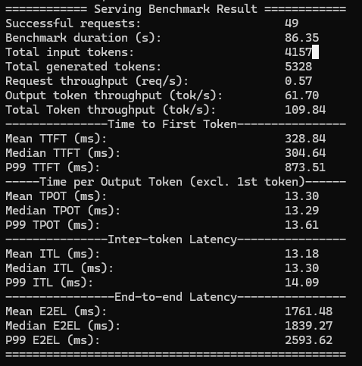

Maximum request concurrency (最大請求數) = 1
只處理一個請求
Max conc = 1
Maximum request concurrency: 1
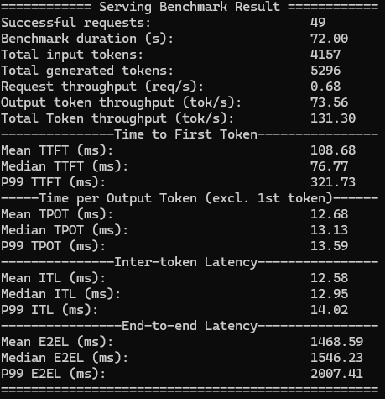

Maximum request concurrency (最大請求數) = 8
處理8個請求
Max conc = 8
Maximum request concurrency: 8
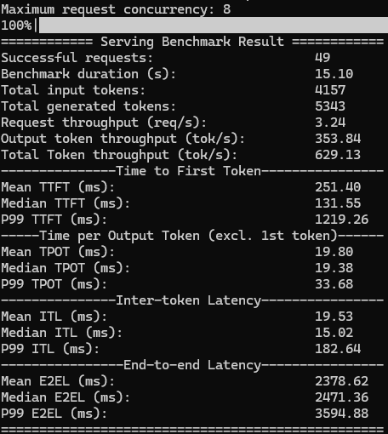

Introducing NVIDIA Jetson Thor, the Ultimate Platform for Physical AI [Link]
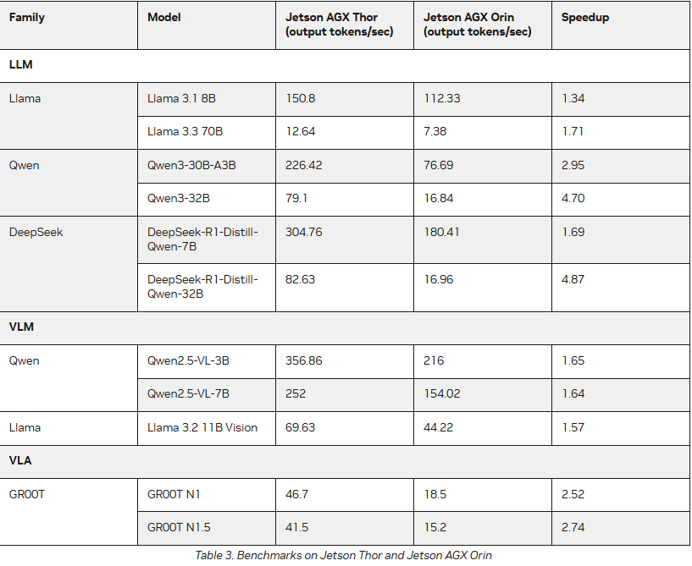

Thor devkit(Test)
Family | Model | AGX Thor (output tokens/sec) | AGX Orin (output tokens/sec) | Speedup
LLM
Llama | Llama 3.1 8B
Llama | Llama 3.3 70B
Qwen | Qwen3-30B-A3B
Qwen | Qwen3-32B
DeepSeek | DeepSeek-R1-Distill-Qwen-7B
DeepSeek | DeepSeek-R1-Distill-Qwen-32B
VLM
Qwen | Qwen2.5-VL-3B
Qwen | Qwen2.5-VL-7B
Llama | Llama 3.2 11B Vision
VLA
GROOT | GR00T N1
GROOT | GR00T N1.5

